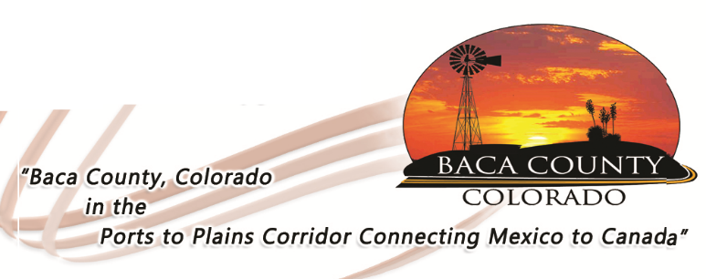
HELP WANTED
DIRECTOR, BACA COUNTY DEPARTMENT OF PUBLIC HEALTH

The Baca County Commissioners are accepting applications for the position of Director for the Department of Public Health Services. This is a full-time position that includes a benefit package. The position requires a current Colorado Registered Nurse License in good standing without restrictions; a Master of Science in Nursing is preferred or Bachelor of Science in Nursing with five (5) years supervisory experience, preferably in public health; current certification in basic cardiac life support; experience working with children, school, or community/public health nursing preferred; and possession of a valid driver’s license issued by the state of Colorado. A list of responsibilities can be found on or website or by contacting the Administrator’s office.

Salary will be dependent upon education, knowledge, and experience.

Applications are available at www.bacacountyco.gov or in the Baca County Administrator’s office at 741 Main Street, Suite 1, Springfield, CO 81073. Applications will be accepted until August 21, 2020.

Baca County is an equal opportunity employer and does not discriminate based on race, age, religion, sex, disability, marital status, or national origin.

