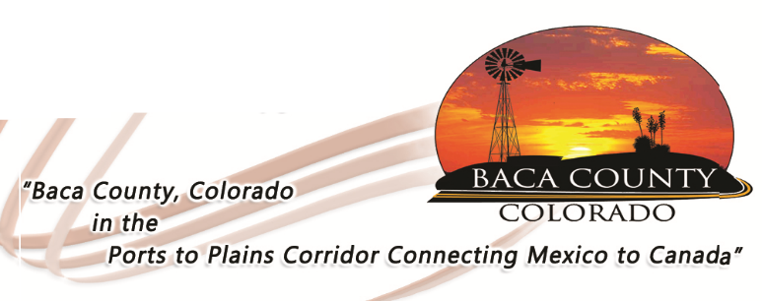

PART-TIME POSITION AVAILABLE

The Baca County Commissioners are looking for part-time drivers for the Baca Area Transportation bus. Baca Area Transportation (BAT) provides bus service for area residents. The bus operates Tuesday through Thursday from 8:30 a.m. up to 1:30 p.m. The position requires a high school diploma or GED, valid driver’s license (CDL not required), be able to pass a background check and pre-employment drug test, and have the patience and compassion to provide transportation services to the elderly and disabled community. Applications are available in the Baca County Administrator’s office at 741 Main Street, Suite 1, Springfield, CO 81073 or on the website bacacountyco.gov. Applications will be accepted at the County Administrator’s office until 4:00 p.m. on Monday, July 6, 2020. Baca County is an equal opportunity employer and does not discriminate based on race, age, religion, sex, disability, marital status, or national origin.

