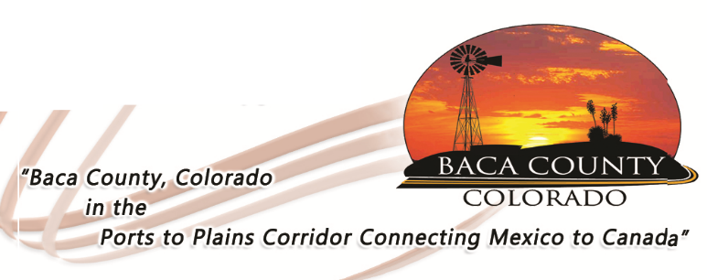
Baca County Commissioners
741 Main Street, Suite 1
Springfield, CO 81073
Telephone: (719) 523-6532 ~ Fax: (719) 523-6584

Glen R. Ausmus, Two Buttes, District I Shiloh Freed, Campo, District II Rick Butler, Pritchett, District III
sausmus@bacacountyco.gov sfreed@bacacountyco.gov rbutler@bacacountyco.gov

Beginning June 1, 2020, the Baca County Commissioners will open the courthouse to the general public. However, social distancing is still necessary and wearing of masks is greatly encouraged. There are also other restrictions that need to be addressed:

- The county clerk and recorder’s office is restricted by Secretary of State mandates. A primary election is set to take place on June 30. For this reason, any business at this office should be through appointment, no more than two people at a time can be accommodated, others will be asked to wait outside or in their car.
- County and District Courts are also governed by the state. You will need to check with that department to see if they will be open to foot traffic.
- The County Library, unfortunately, will continue as it has been doing until further notice.

Note: many of the court’s business can be conducted via phone, on-line, or mail, including vehicle registrations. There is also a drop box at the main entrance that can be used to drop off paperwork, just indicate which department needs to receive the documents. We thank you in advance for your patience and cooperation.

