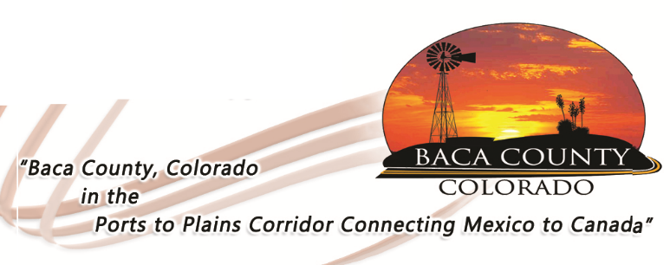
Baca County Commissioners
741 Main Street, Suite 1
Springfield, CO 81073
Telephone: (719) 523-6532 ~ Fax: (719) 523-6584

Glen R. Ausmus, Two Buttes, District I Shiloh Freed, Campo, District II Rick Butler, Pritchett, District III
sausmus@bacacountyco.gov sfreed@bacacountyco.gov rbutler@bacacountyco.gov

NOTICE

Baca County Courthouse Public Closure

In an effort to do our part to prevent the spread of COVID-19, Baca County Public Health in coordination with the Baca County Commissioners will be closing the Baca County offices to walk-in customers starting March 24, 2020. The courthouse building will be open for scheduled court appearances. Limited county staff will be in their respective offices to take your calls and set up appointments. The “ballot drop box” located near the courthouse entrance will be available for property tax payments and license plate renewals. Please ensure that payment envelopes are sealed. Contact the individual offices for other services.

Commissioner’s Office: 719-523-6532
Health Nurse: 719-523-6621
Clerk and Recorder: 719-523-4372
Treasurer: 719-523-4262
Assessor: 719-523-4332

