TRIP SCHEDULING

Current transportation service is provided between the hours of 9:00 a.m. and 3:30 p.m. Riders may call 719.523.6532 to get on the schedule.

Day | Town | Pickup Place | Time
Tuesday | Walsh & Vilas | Your Home | 9:00 a.m.
Wednesday | Springfield | Your Home | 9:00 a.m.
Thursday | Campo | Your Home | 9:00 a.m.

To schedule a pickup:
call Commissioners’ Office
at 719.523.6532

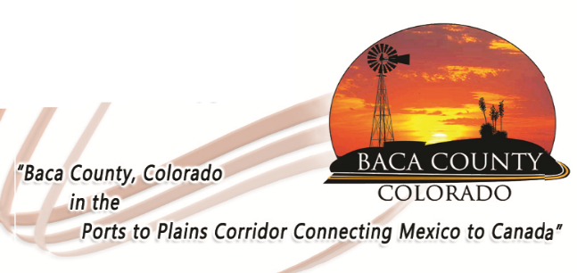
MISSION AND VISION

To provide safe transportation service to all residents of Baca County with priority given to the elderly and disabled. Elderly and disabled residents of Baca County can safely complete banking, attend doctor appointments and needed shopping once a week.

STATEMENT OF RIGHTS

In accordance with the provisions of the American with Disability Act and the Civil Rights Act of 1964, Baca Area Transportation does not discriminate on the basis of disability, race, color, national origin, or gender

BACA COUNTY

741 Main Street
Springfield, CO 81073
719.523.6532
719.523.6584 (fax)

BACA AREA
TRANSPORTATION

PASSENGER INFORMATION

PASSENGER RULES

Passengers have a responsibilty to conduct themselves in a manner which shows consideration for the comfort of other passengers. Baca County has adopted the following Passenger Rules:

- Smoking – smoking or carrying a lighted substance on board an agency vehicle is prohibited.
- Noise – Playing of radios, tape recorders or similar devices (other than by means of an earphone) is prohibited.
- Food – Consumption of food or beverages is prohibited.
- Graffiti – Any writing, spraying, scratching, or otherwise affixing of graffiti on or in facilities or vehicle is prohibited.
- Seatbelts – Passengers must remain in their seats and wear seat belts at all times.
- Priority Seating for Elderly and Disabled Passengers – Passengers in wheelchairs shall have priority over other persons seated in the wheelchair tie-down locations. Other areas designated as courtesy seating for elderly and disabled shall be on a voluntary basis.
- Conduct – Obscene language, loud noise, or boisterous conduct is prohibited.

GRIEVANCE PROCEDURE

If you have any problems or are dissatisfied with the quality of service you are receiving through the Baca County Transportation Program or your service provider, please follow the steps below to resolve the issue.

- If possible, you should call the van driver (Gail Miller – 719.353.1237) to report problems.
- Contact the Baca County Board of Commissioners’ office at 719.523.6532 or 741 Main Street, Suite 1, Springfield.
- If the problem is not resolved, you may contact the Lower Arkansas Valley Area Agency on Aging Director at 1.800.438.3752, P.O. Box 494, La Junta, CO 81050.
- You may file a complaint with:
Colorado Department of Human Services, State Unit on Aging, 1575 Sherman Street, Denver, CO 80203; 1.303.866.2800

BASIC SERVICE

The base transportation service in Baca County operates from 8:30 a.m. to 4:30 p.m., Monday through Thursday, except holidays or when weather does not permit. Eligible riders are Baca County residents. Riders may call bus driver and request a ride or meet at the designated meeting place in each town. This is a curb-to-curb service. This means that riders must get themselves to and from the curb for pickups and drop offs. Drivers do not enter riders’ homes under any circumstances.

Each rider shall have an opportunity to voluntarily contribute towards the cost of service. Under no circumstances will a rider be denied services by the Baca Area Transportation because of a decision to not contribute for services rendered.

A suggested donation is $2.00 to $3.00.

