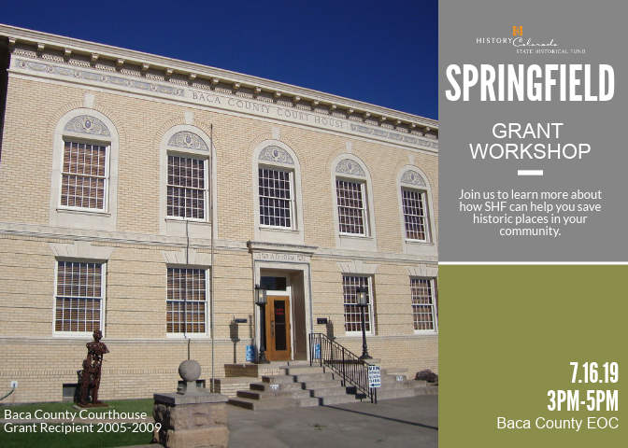

Please join us Tuesday, July 16th from 3-6 p.m. at the Baca County EOC Bldg, 29400 Hwy 287 for a Grant workshop on applying for grants for historic preservation projects. You can register through the following link: https://www.eventleaf.com/SHFSpringfield2019. If you have any questions, please contact Sara Doll at 303-866-3493 or email hc_shf@state.co.us.

