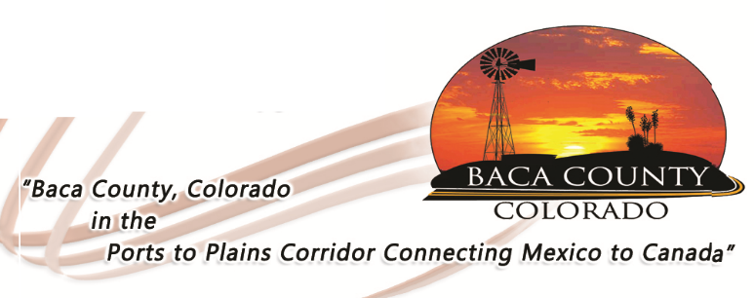
Baca County Commissioners
741 Main Street, Suite 1
Springfield, CO 81073
Telephone: (719) 523-6532 ~ Fax: (719) 523-6584

Glen R. Ausmus, Two Buttes, District I Shiloh Freed, Campo, District II Rick Butler, Pritchett, District III
sausmus@bacacountyco.gov sfreed@bacacountyco.gov rbutler@bacacountyco.gov

IMPORTANT LETTER TO THE RESIDENTS OF BACA COUNTY

The Baca County Board of County Commissioners would like to assure all residents that the Department of Human Services Personal Care Agency (PCA) is up and running as it always has. To all our customers and employees that are involved with the PCA, rest assured it is business as usual and there are NO plans to discontinue these services. If you are hearing information to the contrary, please disregard. If you have ANY questions at all, please feel free to contact either the Baca County Department of Human Services at 719.523.4131; or the Baca County Commissioners office at 719.523.6532.

