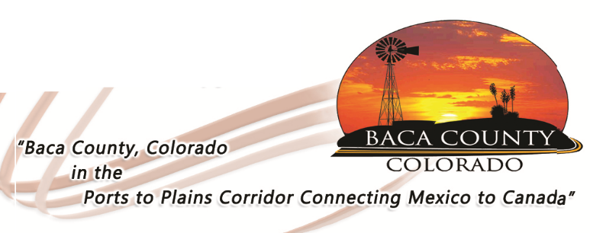
HELP WANTED
PERSONAL CARE AGENCY

The Baca County Commissioners are accepting applications for the Personal Care Agency (PCA) office assistant, who will work out of the Baca County Department of Human Services. This is a part-time position to assist the PCA Manager. The successful candidate should have a high school diploma, valid driver’s license, oral and written communications skills, good customer relations skills, as well as computer skills. The successful candidate will also need to pass a background check and pre-employment drug screen.

Applications are available on the Baca County website (bacacountyco.gov) or in the Baca County Administrator’s office at 741 Main Street, Suite 1, Springfield, CO 81073. Applications are being accepted through Friday, April 26, 2019 at 4:30 p.m.

Baca County is an equal opportunity employer and does not discriminate based on race, age, religion, sex, disability, marital status, or national origin.

