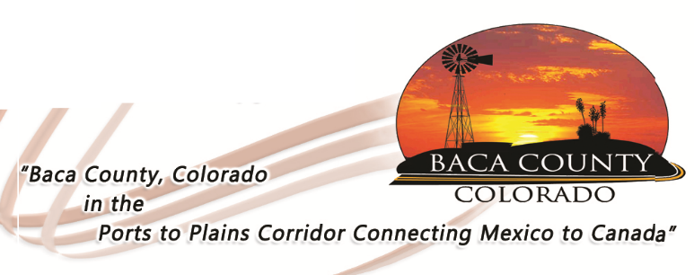
HELP WANTED
PERSONAL CARE AGENCY

The Baca County Commissioners are accepting applications for the Personal Care Agency (PCA) Manager, who will work out of the Baca County Department of Human Services. This position oversees the program that provides in-home services for individuals that qualify for assistance. This position will also hire part-time care providers and billing for services provided. The successful candidate should have a high school diploma, valid driver’s license, oral and written communications skills, as well as computer skills. Financial knowledge would also be beneficial. The successful candidate will need to pass a background check and pre-employment drug screen.

Applications are available on the Baca County website (bacacountyco.gov) or in the Baca County Administrator’s office at 741 Main Street, Suite 1, Springfield, CO 81073. Applications are being accepted through Friday, April 26, 2019 at 4:30 p.m.

Baca County is an equal opportunity employer and does not discriminate based on race, age, religion, sex, disability, marital status, or national origin.

