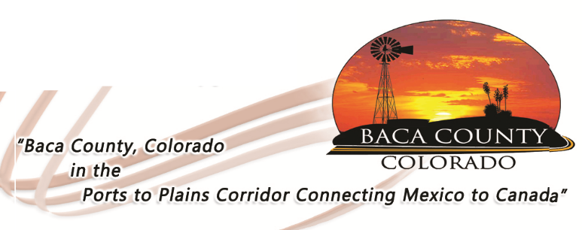

JOB OPENING

The Baca County Commissioners are looking for highly motivated individuals to fill two positions in the Baca County Maintenance Department. These are full-time positions that include medical and retirement benefits. The successful candidates should have a high school diploma; experience in multiple aspects of building and grounds maintenance is desirable. Applications are available in the Baca County Administrator’s office at 741 Main Street, Suite 1, Springfield, CO 81073, or on the website at Bacacountyco.gov. Applications are being accepted through Friday, April 12, 2019. Baca County is an equal opportunity employer and does not discriminate based on race, age, religion, sex, disability, marital status, or national origin.

