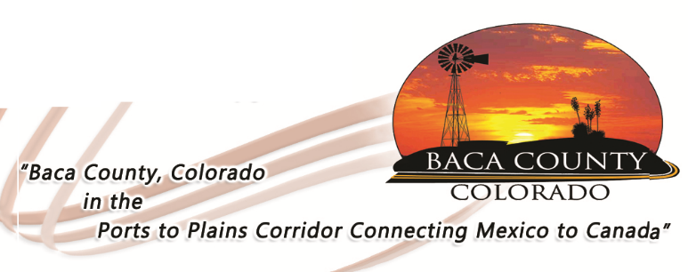
HELP WANTED
DIRECTOR, BACA COUNTY DEPARTMENT OF HUMAN SERVICES

The Baca County Commissioners are accepting applications for the position of Director for the Department of Human Services. This is a full-time position that includes a benefit package.

Essential Functions:
- Plans, organizes, coordinates, and directly supervises a small staff engaged in the administration of state and federally-funded public assistance services programs.
- Confer with BCBCC regarding policies, procedures, personnel matters, fiscal, and other program matters.
- Hire, evaluate, discipline and oversee training of staff.
- Oversees management of the Baca County Personal Care Agency.

Qualifications:
- Bachelor’s degree in a human services-related field (Exceptions may be made for this requirement if the candidate is willing to achieve required education in a reasonable time frame)
- Five years of experience in human services, or similar, public assistance programs
- Three years’ experience managing a program or service; and
- Two years’ experience using data for program changes.
- Must pass a background investigation, motor vehicle check, and drug screen.

License/Certificate:

Certification in Child Welfare and Adult Protective Services Casework Supervisor (or the ability to become certified in a reasonable time frame); must have a valid driver’s license

Salary will be dependent upon education, knowledge, and experience.

Applications are available at www.bacacountyco.gov or in the Baca County Administrator’s office at 741 Main Street, Suite 1, Springfield, CO 81073. Applications will be accepted until March 13, 2019.

Baca County is an equal opportunity employer and does not discriminate based on race, age, religion, sex, disability, marital status, or national origin.

