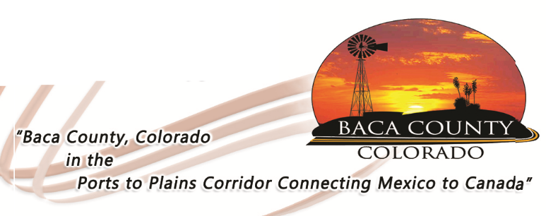

GRIEVANCE PROCEDURE

If you have any problems or are dissatisfied with the quality of service you are receiving through the Baca County Transportation Program or your service provider, please follow the steps below to resolve the issue

- If possible, you should speak with the van driver in person or by calling 719.353.1237; or
- Contact the Baca County Board of Commissioners’ Office at 719.523.6532 or in person or in writing at 741 Main Street, Suite 1, Springfield, CO 81073.
- If the problem is not resolved, you may contact the Lower Arkansas Valley Area Agency on Aging Director at 1.800.438.3752, or in writing at P.O. Box 494, La Junta, CO, 81050; or
- Or you may file a complaint with the Colorado Department of Human Services, State Unit on Aging, 1575 Sherman Street, Denver, CO 80203 or by calling 1.303.866.2800.

