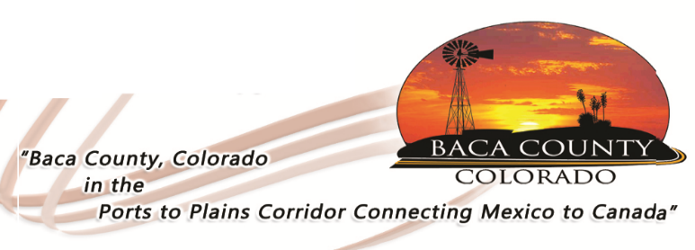
BACA COUNTY FAIR CAMPING SPACE RENTAL

Dates of Camping:
Contact Name:
Address:
Phone Number:
Camping spaces are reserved on a first-come/first-served basis (Campers must be self-contained; no water or sewer is available). Dates and/or spaces will not be guaranteed until fee is paid. Return this form with payment to the Baca County Commissioners’ office at 741 Main Street, Suite 1, Springfield, CO 81073. You can call 719.523.6532 to verify which spaces are still available for the upcoming fair.

20 available: Electrical hookups – 30 amps (16 spaces); $10 per night
or 50 amps (4 spaces); $15 per night

Mark one: # spaces needed: ___________ or Space # Desired: ________________

Note: You may not park your camper/RV in the reserved space until the morning of the first date you request. If Campers/RVs are in the space earlier or longer than requested, the Contact will be billed for additional days unless there are circumstances beyond contact’s control or approved by the County Commissioners. Continuous disregard for this stipulation may result in no longer being able to camp in the fairground spaces.
Make checks payable to Baca County

(For office use only)

Date paid: _________________

Amount: _________________

Check # _________________

