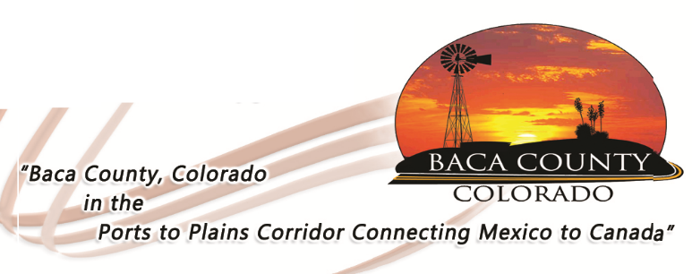

OPEN RECORDS REQUEST FORM
BACA COUNTY

To: Sharon Dubois
Baca County Clerk and Recorder
741 Main Street, Suite 3
Springfield, CO 81073

Pursuant to the Colorado Open Records Act § 24-72-201 and the Baca County Open Record Request (CORA) Policy, please accept this request for the inspection and copying the following public records: (Describe the records with as much specificity as possible).

_______________________________________________________________________________________________________________________________________________________________________________________________________________________________________________________________________________________

I acknowledge that if there is any cost associated with these records, you may estimate the costs and require a deposit prior to beginning the search for documents or records.

My contact information is as follows:

Name:
Telephone:
Address:

Email: ___________________________________

Signature

