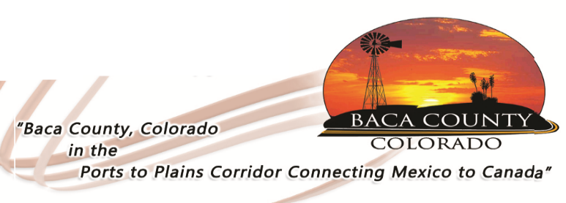
BACA COUNTY FACILITY RENTAL REQUEST (Not for Profit)

Date of Event: Time of event:
Building Requested: _____ Resource Center _____ Minnick _____ Blue Building
_____ Arena _____ Other (list): _______________________________
Event Coordinator:
Organization:
Address:
Phone Number:
Other:
Camping Spaces (Campers must be self-contained; no water or sewer is available)
20 available: Electrical hookups – 30 amps (16 spaces) or 50 amps (4 spaces)
Cost is $10/night for 30 amps; $15/night for 50 amps.

Mark one: # spaces needed: ___________ or Space # Desired: ________________

Note: When signing below, Event Coordinator and represented organization acknowledges they have read, understand, and agree to the terms within the Baca County Facility Rental Agreement.

__________________________________________ _____________________
Signature Date

Cost of building rental is $75 per day for the Minnick Building; $35 per day for all other buildings. A cleaning/security deposit of $200 is due when this request is returned which will be deposited to the county’s account; rental fee is due prior to event. Dates for event will not be guaranteed until deposit is paid. Deposit will be returned when Baca County Maintenance Department has checked the premises for any damage or cleaning needs and adjusted for any cleaning or repairs.

Make checks payable to Baca County

(For office use only)

Key # ________ Key given to: _________________________ Date given: ____________________

Date returned: _________________

Cleaning/Security Deposit returned: Date: _________________
Amount: _______________ Check # ________________

