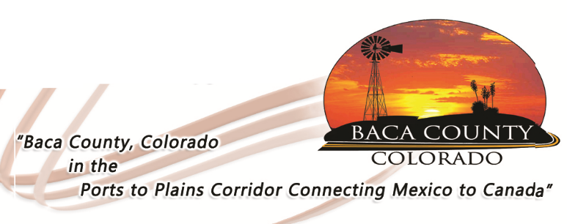
BACA COUNTY FACILITY RENTAL AGREEMENT

GENERAL RULES OF USAGE

This agreement pertains to the buildings; a second agreement is available for stall rental. Cost of rental is $75 per day for the Minnick Building; $35 per day for all other properties. A cleaning/security deposit of $200 is needed to guarantee any dates requested; rental fee is due prior to event. Deposit will be returned when Baca County Maintenance Department has checked the premises for any damage or cleaning needs and adjusted for any cleaning or repairs. Repairs or cleaning by Baca County Maintenance staff will be charged at $25 per hour for labor plus the cost of materials. Repairs or cleaning needed in excess of the $200 deposit will be billed to the event coordinator.

Facility and security/cleaning deposit must be paid when request is made. Baca County Facility Rental Request form must be completed and returned with the deposit. Date and time of event for the requested facility cannot be guaranteed without the Request form and deposit. There will be a $25.00 returned check fee on ALL checks that are returned for insufficient funds.
The Event Organizer and represented organization is responsible for the following:
- any repairs, materials, and labor costs associated with the repair and/or replacement of damage to the facility or its contents.
- making certain the facility used is clean and in good condition following the event.
- emptying trash cans.
- turning off lights and locking all doors and windows at the conclusion of the event.
- pick up and return keys. Keys MUST be returned before noon on the business day following the event unless other arrangements are made.
All For-Profit organizations must provide proof of Liability Insurance coverage prior to the time of the event.

Use or possession of alcoholic beverages and controlled substances is prohibited on the premises. Smoking is prohibited in the buildings. Skateboards, roller skates, scooters, bicycles, tricycles, segways or any wheeled devices, except as needed for medical purposes, are not allowed on the county facilities. Violations of these policies will result in loss of the $200 security deposit on a first offense, and loss of privileges to use the premises on a second offense.

(over)

The Baca County Board of County Commissioners (Board) reserves the right to waive any and all fees at a regular scheduled Commissioner meeting. The Board also reserves the right to deny or restrict use by any person or organization that does not follow the rules of usage as laid out in this document.

CLEANING

The general rule would be to leave the building in the condition you found it. A cleaning checklist is available for all facilities and will be provided to the event coordinator. If you did not receive the checklist and would like one, please contact the County Commissioners’ office at 719.523.6532.

KITCHEN USE

A kitchen is available for use in the Minnick Building, Blue Building, and the Resource Center. For the Resource Center, there is an additional after-hours staffing fee of Ten Dollars ($10) per hour for night and weekend events that need to utilize the kitchen at this facility. Please contact Wanda Cain 719.523.6493 for use of the kitchen at the Resource Center. Use of the kitchen at the Minnick or Blue buildings does not have the same requirement.

Kitchen Rules

- Remove ALL food brought to the event, including any left in the refrigerator or freezer.
- Tie trash bags and deposit in dumpster outside. Sweep and mop kitchen floor.
- Clean counter tops.
- Wash, dry, and put away any dishes used from the facility.
- Clean stove top. Wipe ovens with damp cloth ONLY. DO NOT use cleaning powder or abrasive cleaners on the ovens.
- DO NOT line the oven bottom or completely cover an oven rack with aluminum foil as it could damage the oven and interfere with heat circulation in the oven.
- Turn off all range hoods when finished.
- If you brought it in, take it out.
OTHER

Report any damages or problems encountered with any facility or appliances to the Baca County Commissioners’ office at 719.523.6532.

RENTAL AGREEMENT – 11.7.16

