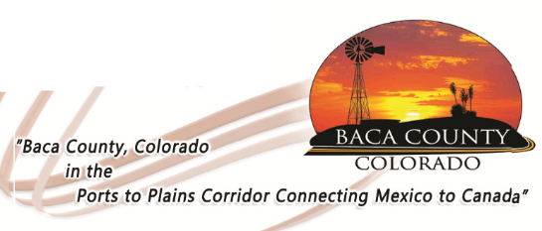
TRANSPORT PERMIT APPLICATION
Permit #
Amount Due:
Baca County
741 Main Street, Suite 1
Springfield, CO 81073
phone 719.523.6532
Fax 719.523.6584
Transport Permit Application Fees: Annual oversize - $250 Annual Overweight - $400
Single trip oversize - $15 Single Trip overweight - $15 plus $5 per axle

Applicant Contact Name: Applicant Contact Phone:

□ Annual Oversize □ Annual Overweight □ Single Trip
□ Pre-Clearance Port: Driver Name:
Payment Method: □ Cash □ Check □ Credit Card
Delivery Method:
□ Walk-in □ Fax Permit To: __________________________ □ Mail Permit To: __________________________
Shipment consists of:

From: To:
Over State Highways:
Mobile Home Use Only
On Following Dates: Serial Number:

Year and Make of Vehicle Tax Authentication:

Vehicle VIN (Last 8 Characters County Being Moved From:

Axles (lbs, ft & ins)
1 2 3 4 5 6 7 8 9
Axles (lbs, ft & ins)
10 11 12 13 14 15 16 17 18
Gross Weight | No. of axles | Distance first to last Axle: | Overall Length: | Trailer length:
Front Overhang: | Rear Overhang: | Height (actual): | Width:
Applicant and/or Company Name (print): Telephone:

Applicant Address (print Street/PO Box , City, State, Zip):

I declare under penalty of perjury in the second degree and any other applicable state or federal laws, that the statements made on this document are true and complete to the best of my knowledge.

Applicant Signature (Required): Date:

Approved by: Date:

