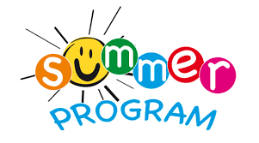
The Baca County Library is excited to announce the
2017 Summer Reading Program.
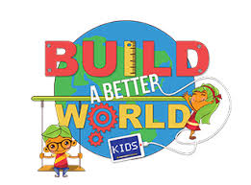
This year’s theme is:
BUILD A BETTER WORLD!
DATE: JULY 10 – 14, 2017
TIME: 9:00 a.m. - 10:00 a.m., Ages 3-8
10:00 a.m. - 11:00 a.m. Ages 9-12

REGISTRATION WILL BEGIN TUESDAY, JUNE 13 THROUGH FRIDAY, JULY 7 AT THE BACA COUNTY LIBRARY. THERE WILL BE A SCHEDULE OF EVENTS AVAILABLE WHEN YOU REGISTER.

WE WELCOME ANY JUNIOR HIGH AND HIGH SCHOOL STUDENTS THAT ARE INTERESTED IN VOLUNTEERING THAT WEEK TO CONTACT THE LIBRARY.

Baca County Library
1260 Main Street, Springfield, CO.
719.523.6962

