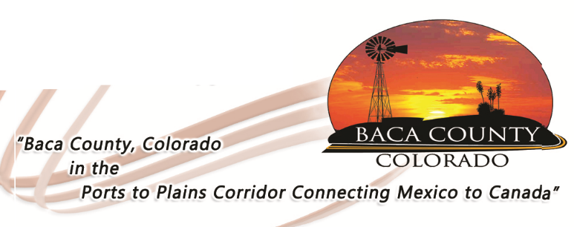
Baca County Commissioners
741 Main Street, Suite 1
Springfield, CO 81073
Telephone: (719) 523-6532 ~ Fax: (719) 523-6584

Glen R. Ausmus, Two Buttes, District I Peter L. Dawson, Campo, District II Rick Butler, Pritchett, District III
sausmus@bacacountyco.gov pdawson@bacacountyco.gov rbutler@bacacountyco.gov

BACA COUNTY COMMISSIONER SUBDIVISION EXEMPTION PROCEDURES

Colorado law prohibits a landowner from dividing land into parcels smaller than 35 acres without County approval. A landowner may subdivide by following one of the two procedures. First, he may plat the land which requires a survey, mapping, and County approval. Second, he may petition the Board of County Commissioners for an exemption from subdivision regulations.

A landowner should complete the application by filling in all the blanks, including providing a legal description. If the land has been surveyed, a copy of the plat should be attached to the application. The application must be signed by the landowner. If the land is owned by husband and wife, one signature is sufficient.

When the completed application is filed, a time should be scheduled for a meeting with the Board. The applicant need not be present for the meeting(s).

In the event the Board approves the exemption, the resolution portion of the petition should be completed, then signed by the Chairman and Clerk. The original will be filed in the Administrator’s Office. Copies will be provided to the applicant and the County Assessor. The application/resolution should be numbered and filed in chronological order.

Board of County Commissioners

NO_______________

APPLICATION FOR EXEMPTION

___________________________________________________________________
Name of Applicant
TO THE BOARD OF COUNTY COMMISSIONERS OF BACA COUNTY, COLORADO

The undersigned owner hereby requests permission to sell and convey ownership of the real property described as follows:

It is respectfully requested that the Board of County Commissioners grant an exemption from the subdivision requirements of CRS 30-28-101.

Date this__________day of ___________________,20____.

Printed Name
Of Potential Buyer: _______________________________________________

Address: _______________________________________________

Printed Name
Of Owner: _______________________________________________

Address : _______________________________________________

Applicant’s Signature: _______________________________________________

RESOLUTION NO__________

WHEREAS, the Board has reviewed the above Application and has considered its merits, and

WHERAS, the Board finds that the proposed division of land is not within the purposes of
CRS 30-28-101.

NOW THEREFORE BE IT RESOLVED that the above Application is granted and the said division of land is hereby exempted from the definition of subdivision pursuant to CRS 30-28-101 (10)(d).

MOVED, PASSED AND ADOPTED this __________day of_____________________,20____.

BOARD OF COUNTY COMMISSIONERS
ATTEST: BACA COUNTY, COLORADO

_________________________________ _______________________________
Clerk and Recorder Chairman

