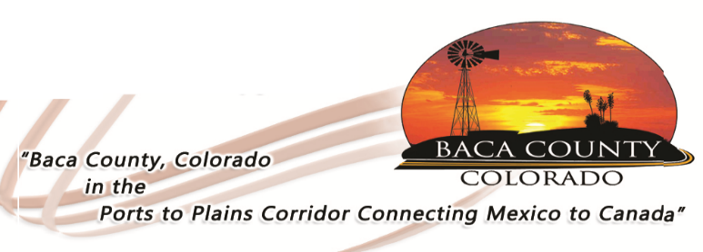

COST SHARE AVAILABLE ON BINDWEED CONTROL

The Baca County Commissioners and the Baca County Weed Board have announced the availability of Fifty Thousand Dollars ($50,000.00) for cost sharing on bindweed control. Landowners and producers in Baca County are eligible to apply for cost share in Baca County for bindweed sprayed from November 1, 2016 to October 31, 2017.

Amounts up to, but not exceeding, 50 percent cost share may be available, depending upon the number of Baca County landowners who apply. The only chemicals eligible for cost share is Tordon and generic brands of Tordon, such as Outpost 22K and Triumph.

To apply for the cost share, producers/landowners need an invoice for chemical, proof of purchase in way of a cancelled check or signed invoice by chemical supplier; legal description of property and a detailed map specifying the location of treated bindweed for the season. The cost share price of chemical will not exceed $95.00 per gallon and cost share on rate will not exceed 24 ounces of chemical per acre for the cost share season.

This information must be turned into the Baca County Commissioners Office, 741 Main Street, Suite 1, Springfield, Colorado by 4:30 p.m. November 1, 2017. For questions, call 719.523.6532.

NO EXTENSIONS OF THE DEADLINE WILL BE GRANTED.

Baca County Chemical Rebate Application

Name:

Address:

City: , Colorado Zip Code:

Phone:

I certify the following information is correct

Signature:
TORDON:
 | Invoice Number | Gallons Purchased | Dollar Amount | Date | Legal/Location | Proof of Purchase | Map Enclosed
1
2
3
4
5
6
7
8
9
10
 | TOTALS:
Note: A detailed map of the location of the property and showing location of area treated for bindweed must be submitted. This map may be a copy or hand map but must be detailed.

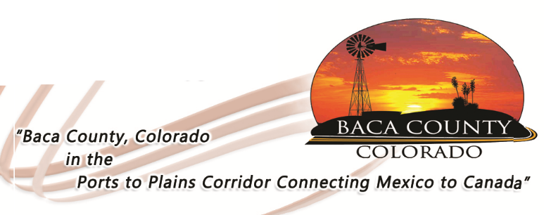

*Note: A detailed map of the location of the property and showing location of area treated for bindweed must be submitted. This map may be a copy or a hand map but must be detailed.

Use the following grid to create a detailed map showing location, County roads, and any other details as to access to the field location and location of Tordon application.

