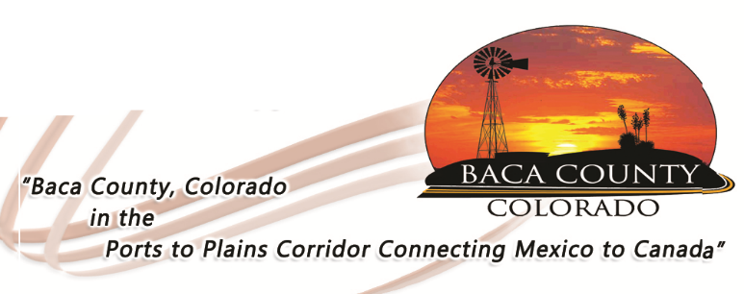
Baca County Commissioners
741 Main Street, Suite 1
Springfield, CO 81073
Telephone: (719) 523-6532 ~ Fax: (719) 523-6584

Glen R. Ausmus, Two Buttes, District I Peter L. Dawson, Campo, District II Rick Butler, Pritchett, District III
sausmus@bacacountyco.gov pdawson@bacacountyco.gov rbutler@bacacountyco.gov

To Whom It May Concern:

The Baca Board of Commissioners hereby confirms that Baca County has no zoning or land use regulations at the current time, except regulations regarding septic tanks, septic fields, and leach lines. Baca County does not require building permits or other land use permits for the construction of renewable energy or transmission projects. Baca County does, however, require permits for construction in public right-of-way and permits for oversize vehicles on county roads. Baca County does require compliance with all state and federal regulations. Baca County also requires applications for subdivision exemptions pursuant to Colorado State Law.

The county does not waive any powers it has to enact regulations in the future, its 1041 powers, or any other powers available to it under Colorado law.

Sincerely,

The Board of Baca County Commissioners

