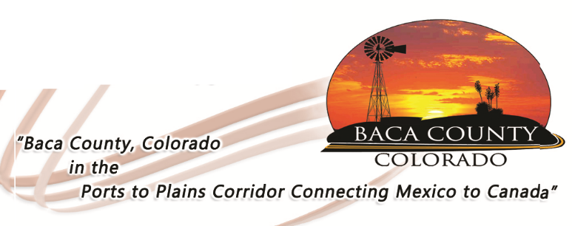
Baca County Commissioners
741 Main Street, Suite 1
Springfield, CO 81073
Telephone: (719) 523-6532 ~ Fax: (719) 523-6584

Glen R. Ausmus, Two Buttes, District I Peter L. Dawson, Campo, District II Rick Butler, Pritchett, District III
sausmus@bacacountyco.gov pdawson@bacacountyco.gov rbutler@bacacountyco.gov

NOTICE REGARDING COUNTY ROAD RIGHT-OF-WAY

Most of the county road right-of-way is 60 feet in width; some are as much as 100 feet. Even though the road itself does not span the full 60/100 feet, the area not driven upon is designated for maintenance of the road, ditches and drainage systems, snow storage, signage, and utilities. The Baca County Commissioners want to remind all residents that Baca County reserves the right to make full use of all the county road right-of-way. The county also reserves the right to remove any encroachments on the county road right-of-way including fences, structures, and growing crops, as well as seek reimbursement from the land owner causing said encroachment for the cost for this removal.

